Methigion CC Captains report 2017

Played 19
Won 7
Lost 11
Drawn 1

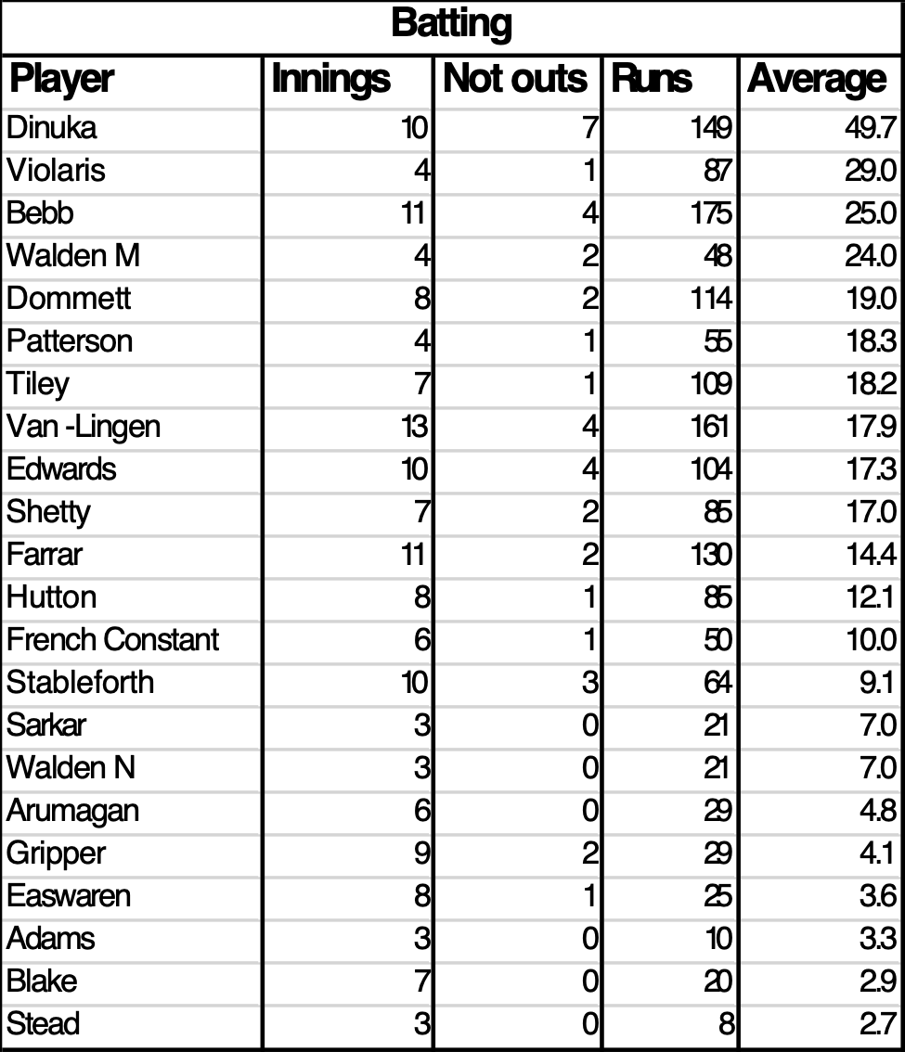

Bowling
Player | Overs | Wickets | Runs | Average | Economy rate(runs/over)
Arumagan | 10 | 6 | 70 | 11.7 | 7.0
Dinuka | 39.2 | 13 | 165 | 12.7 | 4.2
Walden M | 11 | 3 | 39 | 13.0 | 3.5
Bharat | 10 | 5 | 67 | 13.4 | 6.7
Stableforth | 14.1 | 6 | 87 | 14.5 | 6.2
Edwards | 39.4 | 12 | 190 | 15.8 | 4.8
Violaris | 15 | 4 | 64 | 16.0 | 4.3
Violaris | 15 | 4 | 65 | 16.3 | 4.3
Patterson | 17 | 5 | 83 | 16.6 | 4.9
Van-lingen | 48 | 15 | 261 | 17.4 | 5.4
Sarkar | 19 | 7 | 138 | 19.7 | 7.3
Gripper | 21 | 5 | 113 | 22.6 | 5.4
Farrar | 43 | 11 | 261 | 23.7 | 6.1
French-Constant | 19.4 | 3 | 100 | 33.3 | 5.2
Walden N | 9 | 1 | 79 | 79.0 | 8.8
Tiley | 15 | 1 | 99 | 99.0 | 6.6

Catches |  | Run outs
Easwaren | 1
Dinuka | 1
Farrar | 2
Shetty | 2 | 1
Hutton | 1 | 1
Edwards | 3
Bebb | 1
Stableforth | 1
Van-lingen | 3 | 2
Violaris | 1
Walden M | 1
Blake | 1

